Basic of Java
- What is Java?
- OOP language and computing platform
- Write once run anywhere
- Code can run on any machine with Java virtual machine (JVM).

- History and feature of java.
- Developed by Sun Microsystems 1995: mobile apps and web applications
- Object oriented programming: Organize code into reusable classes and objects
- Platform Independent: Compiles to bytecode that runs om any JVM
- Robust and Secure: Automatic memory management (garbage collection) and strong exception handling for reliability
- Rich Ecosystem: Offers extensive libraries, frameworks and tools for complex development
- C++ vs java
- Both are oops language
- C++ is known for performance and low-level control, making it ideal for systems programming and game development
- Java prioritize probability, simplicity and automatic memory management, excelling in enterprise and web applications
- C++ is different OS recompile the program and Java write once runs anywhere
- C++ compilation is faster than java
- C++ allow multiple inheritances and java doesn’t allow multiple inheritances
- C++ Supports operator overloading and java doesn’t support

- Hello Java program.
public class Hello {
public static void main (String [] args ) {
System.out.println("Hello GBM SOFTECH");

}
}

Output:-
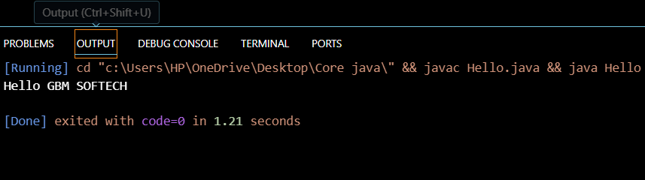
- Internal How to set the path?
- Install JDK from oracle website
- Open the JDK file
- Go to the bin file copy the file path
- Open setting go to the environment variable click on advance click on new click on path add new path paste the path click on save

- JDK, JRE, and JVM (Java Virtual Machine)
- JDK Stands for Java Development kit (Develop applications of java)
- JRE java runtime environment (is used for software package that provide Java class libraries that require to run java applications)
- JVM Stands for Java virtual machine (it’s used for to run the java program its very useful because is give us to write once and run anywhere)

- JVM memory management
- Automatically handles object allocation and deallocation
- Primary use a garbage collector to free up heap space

- Internal Details of JVM
- Key memory settings
- A] -Xms : Initial heap size
- B] -Xmx : Maximum Heap size
- C] -XX : MaxMetaspaceSize : Sets the max size for metaspace

- Unicode System, Operators, Keywords, and Control Statements like if-else, switch, for loop, and while loop
- Unicode System:
It’s use to support multiple languages
Each character assigned unique code point
Unicode allows program to handle characters like English, Hindi, Marathi
Characters are stored using UTF-16 encoding

Code:-
public class uni {
public static void main(String[] args) {
char ch = '\u0915';
System.err.println(ch);
}

}
Output:-
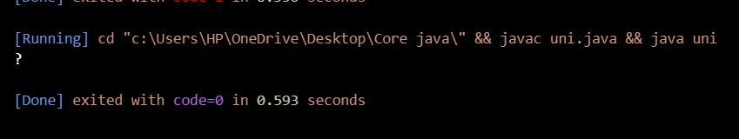
- Operators: operators are used for perform operations on variables and values
Arithmetic operators: + - * / %
Relational Operators: > ,<, >=, <= , ! , == , !=
Bitwise Operators: & | ^ << >>
Logical Operators: && || !
Assignment Operators: = ,+= ,- = , *= , /=
Unary Operators: ++ --

Code:-
public class op {
public static void main(String[] args) {
int a = 10;
int b = 10;
int sum = a + b ;

System.out.println("The total of numbers "+ sum );

}

}

Output:-
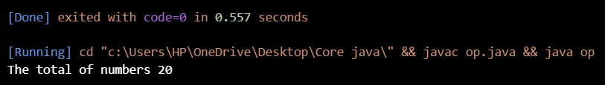
- Keywords: Keywords are reserved words in programming language that have predefined meanings and cannot be used as variable names
int, float, double, if, else, switch, for, while, do, class, public, static, void, return, break, continue

- Control Statements: Control Statements are used to control flow of execution of a program
- If-else statement: used to execute based on condition
Code:-
- public class ifelse {
- public static void main(String[] args) {
- int age= 18;
- if ( age >= 18 ){
- System.out.println("Eligible to vote");

- }
- else {
- System.out.println("Not Eligible ");
- }
- }

- }

- Switch statement: used to select one block of code from multiple options
- public class swi {
- public static void main(String[] args) {
- int day =2 ;
- switch (day) {
- case 1:
- System.out.println("Monday");
- break;
- case 2:
- System.out.println("Tuesday");
- break;
- default:
- System.out.println("Invalid day");
- break;
- }
- }

- } 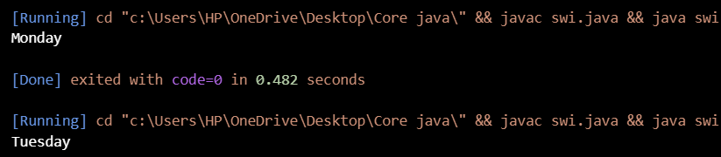

- For loop: used when the number of iterations is known
- public class forloop {
- public static void main(String[] args) {

- for (int i=1;i <= 10;i++){
- System.out.println(i);
- }
- }

- }

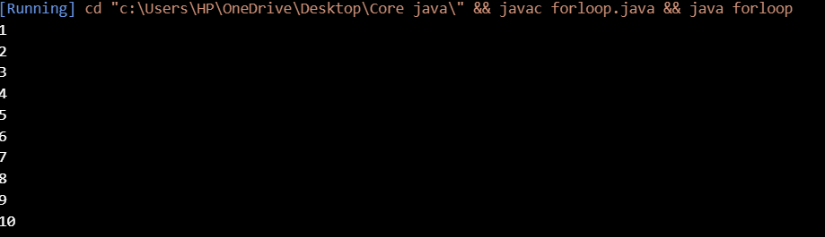

- While loop: used when the number of iterations is not known in advance
- public class dowhile {
- public static void main(String[] args) {
- int i=1;
- while (i <= 5) {
- System.out.println(i);
- i++;

- }
- }

- }

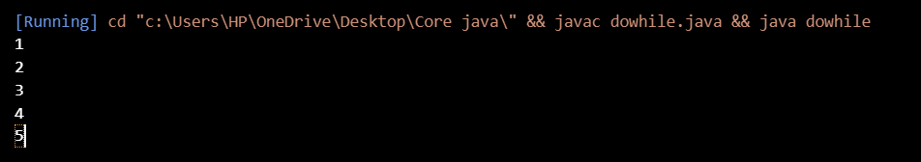

Class, Objects, and Types of Classes
1. Naming conventions of Java
- These are the set of rules and best practices used to set name of class, variables, methods, constants and packages
2. Class, object and features
- Class
- Class is a blueprint or template used to create objects
- If defines variables and methods
- Doesn’t occupy memory

- Objects
- Object is real world entity and instance of a class
- Occupy memory
3. Object declaration and initialization
- Object Declaration
- Object declaration means creating reference variable
- At this stage, Memory is not allocated

- Object initialization
- Assigning memory to the object and setting its initial values
- Done using new keyword
Code:-
class student{
int rollno;
String name;
}

public class ObjectDI {
public static void main(String[] args) {
student s1 =new student();
s1.rollno=9;
s1.name="Shriram";
System.out.println(s1.rollno+" "+s1.name);
}

}
Output: -
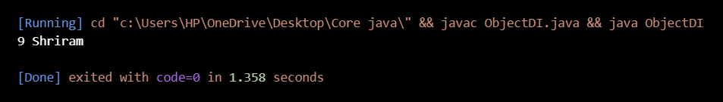

4. The life cycle of an object
- Object Creation → Object Usage → Unreachable → Garbage Collection → Destruction
5. Anonymous object in Java
- Created without assigning
- Only used once and cannot be reused

Packages in java
- How to declare a package in a company project
- Is a namespace that groups related classes and interface together
- Improve code organization
- Avoid name conflicts

- Package naming conventions
- Maintain uniqueness, readability and organizations
- Use lowercase letter only
- Follow reverse domain name
- Avoid special characters
- Do not use java keywords
- Use meaningful name
- One package per directory

- Sub packages
- Package inside another package

- Types of packages such as user-defined packages, built-in packages
- Built-in packages
- Predefined Packages
- Imported using import keyword
- Provide readymade classes and interfaces
- java.lang:- Core classes
- java.util:- Data structures
- java.io:- Input and output operations
- java.sql :- Database connectivity
- java.net:- Networking
- java.time:- Date and time api
- User-defined packages
- Created by programmers to organize their own classes
- Created using package keyword

- Importing packages in Java
- Allow us to use classes and interfaces defined in another packages
- Reuse existing classes
- Ways
- Import specific class
- Import all classes from package
- Without using import statement
- Static import

Data Types in java
- Data types in java
- Data types specify the type of data variable can store
- Primitive data types
- Primitive data types store simple values directly in memory
- 8 primitive data types
byte | 1 byte | Small integers
Short | 2 bytes | Short integers
Int | 4 bytes | Whole number
Long | 8 bytes | Large integers
Float | 4 bytes | Decimal values
Double | 8 bytes | Precise decimals
Char | 2 bytes | Single character
boolean | 1 bit | True or false

- Non-primitive data types
- Non-primitive data types store references of objects
- Example:- string ,arrays,classes,interfaces

- Memory allocation of primitive and non-primitive data types
- Two types of memory
- Stack memory ()
- Heap memory
- Primitive Data types
- Primitive data store actual values
- Stack memory for local variables
- Inside object memory (if they are instance variables)
- Non-Primitive data types
- Store references not actual data
- Object data -> heap memory
- Refence variable -> Stack memory

Code:
class test{
int s=10;
}

public class prinonpri {
public static void main(String[] args) {
int a =10;
test t = new test();
System.out.println("Summation of two numbers "+(a+t.s));
}
}

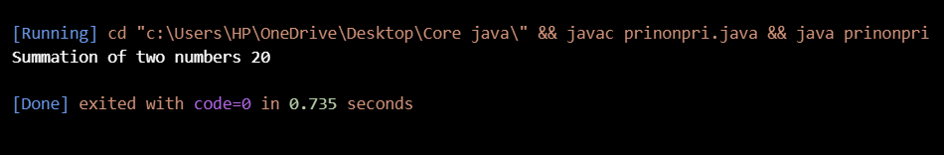

Variables, Constraints, and Literals
- Variable declaration and initialization
- Variable declaration
- Defining data types and name variable
- Reserves memory
- Doest not assign value

- Variable initialization
- Assigning value to variable

- Types of variables such as local variables, instance variables, and static variable
- Types Of Variables

- Local variables
- Declared inside methods
- Must be initialized before use
- Stored in stack memory

- Instance variable
- Declared inside class outside methods
- Get default Values
- Stored in heap memory

- Static variable
- Declared using static
- Shared among all objects
- Stored in method area

- Scope and memory allocation of variables
Variable type | Scope | Memory allocation | Lifetime
Local | Method / block | Stack | Method Execution
Instance | Object level | Heap | Object lifetime
Static | Class level | Method area | Program Execution

Methods in java
- Methods in java
- A method is a block of code performs a specific task
- It’s used to reuse code, improve readability and reduce complexity
Code
class demo{
void show(){
System.out.println("Hello Shriram");

}
}

public class method1 {
public static void main(String[] args) {
demo d1 = new demo();
d1.show();
}

}

Output:-
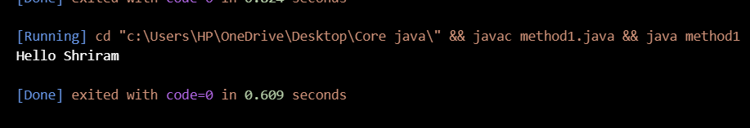

- Use of method in java
- Code reusability
- Write code once and use it multiple times
- Improves readability
- Easy to read and understand
- Each method performs specific task
- Reduces code Duplication
- Avoid writing same logic again and again
- Save time and efforts
- Easy Debugging
- Errors can be found and fixed easily
- Each Method can be tested independently
- Better program Structure
- Breaks a large program into smaller modules
- Follow Modular Programming Approach
- Improves maintainability
- Changes can be made in one method without affecting other parts of the program
- Supports Abstraction
- Shows what the method does not how it does
- Implementation details are hidden
- Enables Object-Oriented programming
- Methods represent behavior of objects
- Used in inheritance, polymorphism and encapsulation

- Method declaration, the method signature
- Method Declaration
- Defines a method by specifying how it is written and what it does
- Tells about method name return type parameters access modifier
- Method Signature
- Is the unique identity of a method

- Types of methods in java: predefined method, user-defined methods: instance method, static method
- Predefined method
- Methods already provided by the java api
- Examples: println(), sqrt(),length()
class meth{
void length(){

int len ="JAVA".length();
System.out.println(len);

}
}

public class pdmethods {
public static void main(String[] args){
meth m1=new meth();
m1.length();

}
}
- User-defined method
- Methods created by the programmer to perform specific task
class user{
void show(){
System.out.println("Hello World");
}
}

public class udmethods {
public static void main(String[] args) {
user u1= new user();
u1.show();

}

}

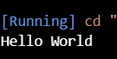

- Static methods
- Declared using static
- Called using class name
- No object required
class stat{
static void display(){
System.out.println("Static method");

}
}

public class staticmethod {
public static void main(String[] args) {
stat.display();

}

}
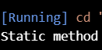

- Instance methods
- Non-Static methods
- Called using object
- Belong to an object
- class insta{
- void show(){
- System.out.println("Instance METHOD");
- }
- }

- public class instmetho {
- public static void main(String[] args) {
- insta obj = new insta();
- obj.show();

- }

- }
- 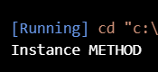

- Methods with parameters
- Accepts values as input
- class paramters1{
- void add(int a, int b){

- System.out.println("Addition of two numbers "+(a+b));
- }
- }

- public class paramethods {
- public static void main(String[] args) {
- new paramters1().add(10, 20);

- }

- }

- 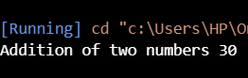
- Methods with return value
- Return a value to caller
class retun{

int square (int a){
return a*a;
}
}

public class retunvaluemeth {
public static void main(String[] args) {
retun obj=new retun();
System.out.println(obj.square(5));

}

}

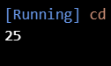

- Method overriding
- Multiple methods with the same name but different methods
- Abstract methods
- Declared using abstract
- No method body
- Must be implemented by subclass
- Final methods
- Declared using final
- Cannot be overridden
- Calling of method
- Invoking or executing method to perform a specific task
- Calling A static method
- No object required
- Called using class name
- Calling an instance method
- Object is required
- Called using object reference
- Calling a method with parameters (passing values while calling the method)
- Calling a value with return value (The return value can be stored or used)
- Calling one method from another method (A method can call another method inside the same class)
- Calling methods using this keyword (used to call current class method)
- Calling method using super keyword (used to call parent class method)

- Java main method
- Entry point of a java program
- Execution starts from the main method

- Return type in java
- Void return type
- Method does not return any value
- Used when result is not required
- Primitive return type
- Returns a single value of primitive data type
- Non-primitive type
- Returns an object or references
- Array as return type
- A method can return array
- Class type as return type
- Return an object of a class

Constructor in Java
- What is Constructor in Java?
- Is used to initialize object of class
- Automatically called when an object is created using new keyword
- Same as name class
- Doesn’t have return type
- Can be overloaded
- Types of Constructors: Default and parameterized constructors
- Default Constructor
- NO parameters
- Provided by compiler if no constructor is defined
- Parameterized constructor
- Accepts parameters
- Initializes object with values
- Copy constructor (User Defined)
- Copies values of one object to another
- Not built-in in java
Constructor | Method
Same name as class | Any name
No return type | Has return type
Called automatically | Called explicitly
Used to initialize object | Used to perform task

- Java constructor overloading
- More then one class in the same class with different parameter list
- Parameter list must be different
- Access modifiers can be different
Constructor overloading | Method overloading
Same class name | Same method name
No return type | Has return type
Used For initialization | Used for operations

- Constructor chaining in Java
- Process of calling one constructor from another constructor within same class or parent class
- Types of constructor chaining
- Within the same class using this()
- Within the parent class using super()
- Copy constructor in Java
This() | Super()
Calls same class constructor | Calls parents class constructor
Used for constructor overloading | Used in inheritance
Must be first statement | Must be first statement

Modifiers in Java
- Modifiers in java
- Used to change behaviour, access level or properties of classes, methods, variables and constructors
- What are an Access modifier and a non-access modifier in Java?
- Types of access modifiers like private, default, protected, and public
- Types of non-access modifiers like abstract, final, native, static, strictfp, synchronized, modifier, transient, and volatile.
- Access modifier
- They control visibility of classes, methods, variables and constructors
- Types of Access modifier
Modifier | Access level
Public | Accessible from anywhere
Protected | Accessible within same package and subclasses
Default | Accessible within same package
Private | Accessible only within the same class
- Non access modifier
- They define behaviour or characteristics of classes, methods and variables
- Common Non access modifiers
- Static (Belong to class, not object)
- Final
- Final variable -> value cannot change
- Final method -> cannot be overridden
- Final class -> cannot be inherited
- Abstract (used with abstract class and methods, abstract method has no body)
- Synchronized (used in multithreading allow only one thread at a time)
- Volatile (used in multithreading, ensures latest value is read from memory)
- Transient (used in serialization, prevents variable from being serialized)
- Native (used for methods implemented in other languages)

Static Keyword
- What is Static Keyword
- To define class level numbers
- Belong to the class not to individual objects
- Static variable
- Shared among all object of a class
- Static method
- Belongs to the class and can be called without creating an object
- Static block, instance block
- Static block
- Executes once when class is loaded
- Used to initialize static data
- Instance block
- Executes every time an object is created
- Runs before constructor
- Static Nested Class in Java
- Is a class inside another class marked as static
- Difference between static variable and instance variable, static method and instance method, static block, and instance block
- Static variable and Instance variable
Static variable | Instance variable
Shared among all objects | Separate copy for each object
Class level | Object level
Stored in method area | Stored in heap
Accessed using class name | Accessed using object
- Static method vs instance method
Static method | Instance method
Called using class name | Called using object
Access static members only | Accesses both
No this keyword | Use this
faster | Slightly slower
- Static block Vs instance Block
Static block | Instance block
Executes once | Executes for every object
Executes when class load | Executes during object creation
Used to initialize static data | Used to initialize instance data

Final Keyword
- Final keyword
- Is used to restrict modification
- Once something declared in final it cannot be changed
- Applied to :- variable, method, class
- Final variable
- Is a constant
- Final method
- Cannot be overridden by a child class
- Final class
- Cannot be inherited
- Final and abstract cannot be used together

Inner Class in java
- What is Inner Class in Java?
- A class is defined inside another class
- Helps in logical grouping, encapsulation and better readability
- Types of Inner Class in Java
- Member inner class (Non-static)
- Defined inside a class
- Needs outer class object
- Static nested class
- Declared using static
- No outer class object needed
- Can access only static members
- Local inner class
- Defined inside a method
- Scope limited to that method
- Anonymous inner class
- No class name
- Used for one-time use
- Often used with interfaces or abstract classes

Super keyword
- Super Keyword
- Used to refer to the immediate parent class object
- Mainly used in inheritance
- Calling of superclass instance variable
- To access an instance variable of the superclass from subclass we use the super keyword
- Superclass constructor
- Is a constructor of parent class
- It’s called from the subclass using the super() keyword
- Superclass method
- Superclass method is a method defined in the parent class
- accessed or called from the subclass using the super keyword, especially when the method is overridden

Encapsulation in Java
Encapsulation in Java
process of wrapping data (variables) and methods into a single unit (class) and restricting direct access to data.
How to achieve encapsulation
• Declare variables as private
• Provide public getter and setter methods
Data Hiding
protecting data from unauthorized access using private access modifier.
Tightly Encapsulated Class
A class is tightly encapsulated if:
- All data members are private
- Access is only through public methods
Getter and Setter Methods
- Getter → reads data
- Setter → modifies data
- Naming Convention of Getter and Setter
Method | Naming
Getter | getVariableName()
Setter | setVariableName()
Boolean Getter | isVariableName()

Inheritance
Inheritance in Java
allows one class to acquire properties and methods of another class using extends
Is-A Relationship
Inheritance represents an Is-A relationship.
Aggregation and Composition
Aggregation (Weak relationship)
- One object uses another object
- Objects are independent
Composition (Strong relationship)
- One object depends on another
- Child object cannot exist alone
- Types of Inheritance
- ✔ Single
✔ Multilevel
✔ Hierarchical
- ❌ Multiple (not supported using classes)

POLYMORPHISM
Polymorphism in Java
Polymorphism means one method, many forms.

2️⃣ Types of Polymorphism
Compile-time Polymorphism
- Achieved using Method Overloading
Runtime Polymorphism
- Achieved using Method Overriding
- Static and Dynamic Binding
Static Binding | Dynamic Binding
Compile time | Runtime
Method Overloading | Method Overriding
Final/Static methods | Overridden methods
Method Overloading
Same method name with different parameters.
Method Overriding
Subclass provides its own implementation of superclass method.

ABSTRACTION
Abstraction in Java
Abstraction hides implementation details and shows only essential features.
How to Achieve Abstraction
1️⃣ Abstract Class
2️⃣ Interface

